|  |
| --- |
| Dyalog LTD |
| MiServer 3.0 |
| Quick Start Guide |

|  |
| --- |
| August 2016 |

Contents

Getting Started 2

The MiServer Project 2

Obtaining MiServer v3.0 2

Where to Put MiServer? 2

Start MiServer 3.0 4

## Getting **Started**

This document explains how to obtain, install and start MiServer.

### The **MiServer** **Project**

MiServer is open source and intended to be a collaborative, community-based, project. Users are encouraged to submit their code and suggestions to be considered for inclusion in MiServer.

## Obtaining MiServer v3.0

MiServer is located in a Git respository on GitHub at <https://github.com/Dyalog/MiServer>.

Git is a popular distributed version control system and GitHub is a web-based Git respository hosting service. Git is a command line based system, but many GUI interfaces have been developed on a variety of platforms.

There are two basic options to obtain MiServer. Which one you choose may be based on how you intend to use MiServer. You can, of course, change your mind in the future and use the other option.

1. Just download the zip file containing the latest release of MiServer.   
   Choose this option if:
   * You just want to quickly get started learning and using MiServer.
   * You want the latest stable "official" release of MiServer.
2. Install git on your local platform and clone the GitHub repository. If you're not familiar with git, you may want to install a GUI-based git client to make things easier.   
   Use this option:
   * If you want to be able to get the latest updates to MiServer, even before they are "officially" released.
   * If you want to participate in the MiServer Project by contributing code.

### Where to Install MiServer?

Whether you have a zip file or have decided to clone the GitHub repository, you'll need to select a folder in which to install MiServer.



How you plan to use MiServer may influence where you install it.

If you're planning on running MiServer locally for your own use, or as a development environment, good choices of folder locations include:

* Your desktop folder – the miserver workspace will be easily clickable
* Your My Documents folder
* A folder off of the root folder (e.g. c:\miserver\)

If you're planning to host this installation of MiServer

* A folder off of the root folder (e.g. c:\miserver\)



It is NOT recommended that you install MiServer where Dyalog APL is installed.

We'll use "c:\miserver\" as the place where we've installed MiServer in all MiServer documentation. So, substitute your actual location whenever you see "c:\miserver\"

#### Option 1 - Downloading MiServer v3.0

1. Open your web browser and navigate to <https://github.com/Dyalog/MiServer/releases>
2. Click and download the appropriate source code file (.zip or .tar.gz) for the latest release.
3. Unzip the contents to a folder of your choosing.  
   For the purposes of this document, we'll assume you've unzipped to **c:\miserver\**

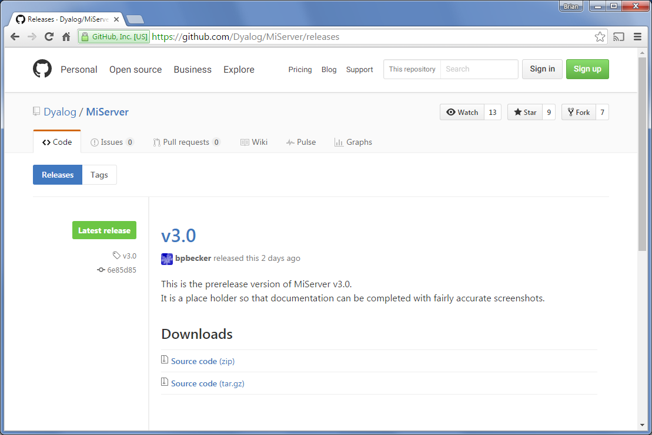

#### Option 2 - Cloning the MiServer Repository

This option requires that you install git on your machine. As this document's focus is MiServer and not git, please refer to <https://git-scm.com/> for more information on git.

##### Installing git

There are a number of ways to install git depending on your platform and whether you prefer a command line or GUI interface. GUI clients will typically install git as a part of their installation process. Among the many GUI options for Windows and Mac are:

* SourceTree - <https://www.atlassian.com/software/sourcetree>   
  (this is what most of the MiServer development team members use)
* GitHub Desktop - <https://desktop.github.com/>

If you use GUI front end for git, it will have a way to clone the MiServer v3.0 respository from <https://github.com/Dyalog/MiServer.git>.

Please refer to the documentation for your git GUI front end for the specifics of how to do this.

## Start MiServer 3.0

1. Load the miserver workspace

**)load c:\miserver\miserver**

c:\miserver\miserver.dws saved...

Start './SampleMiSites/MS3' ⍝ Run the MiServer v3.0 sample site

1. Start MiServer

Cursor up, insert a 1 before Start and press enter  
 **1 Start './SampleMiSites/MS3'** ⍝ Run the MiServer v3.0 sample site   
Development environment loaded

MiSite "c:\git\miserver\SampleMiSites/MS3\" loaded

MiServer for "./SampleMiSites/MS3" started on http://192.168.223.20:8080

Running in Debug mode (configured by setting <Production> in /Config/Server.xml)

What's all this mean?

* Development environment loaded  
  Providing Start a left argument of 1 loads the development environment which loads all the classes needed to be able to edit pages from the root of the workspace.
* MiSite "c:\miserver\SampleMiSites/MS3\" loaded  
  The right argument to Start is the path to the folder containing your website.  
  MiServer includes a number of sample web sites. In this case the MS3 sample website is located in the SampleMiSites folder within the MiServer installation.  
    
  When you create your own websites, don’t store them within the \miserver\ folder as this may cause conflicts or loss of data when you download updates to MiServer. You should store your own websites in a folder outside of the MiServer folder structure.
* MiServer for "./SampleMiSites/MS3" started on http://192.168.223.20:8080  
  This means that MiServer started successfully and listening on port 8080. The port is configurable. If you’re using Dyalog for Windows version 15.0 or later, you can Ctrl-click on the displayed web address to open it in a browser.
* Running in Debug mode (configured by setting <Production> in /Config/Server.xml)  
  Debug mode makes it easier for you to diagnose and recover from programming errors that may occur as you develop your website.

1. Use the browser of your choice to navigate to [**http://localhost:8080**](http://localhost:8080) or the IP address that was shown in the MiServer start message.

**Ta Da! You’ve now installed and started MiServer!**